**1. Identification of the substance/ mixture and of the company/ undertaking**

**1.1. Product identifier**

Trade name : HUNTEX CNT-65

Chemical Name : Mixture of surfactants.

**1.2. Recommended use of the chemical and restrictions on use**

Recommended use : Textile auxiliary

Non-recommended : none known.

**1.3. Details of the supplier of the safety data sheet**

Company : HUNG XUONG CHEMICAL CO., LTD.

Telephone : +84 272 377 8055/56

Telefax : +84 272 377 80

E-mail : info@hungxuong.com

**1.4. Emergency telephone number**

Emergency : +84 272 377 8055

Information :

**2. Hazards identification**

**2.1. Classification of the substance or mixture**

**GHS Classification and classification according to Regulation on classification and labeling of chemicals – Circular Number 32/2017/TT-BCT**

Skin corrosion/irritation: Category 2

Serious eye damage/eye irritation: Category 1

Aquatic Chronic: Category 3

**2.2. Label elements**

**GHS Label element**

Hazard pictograms : 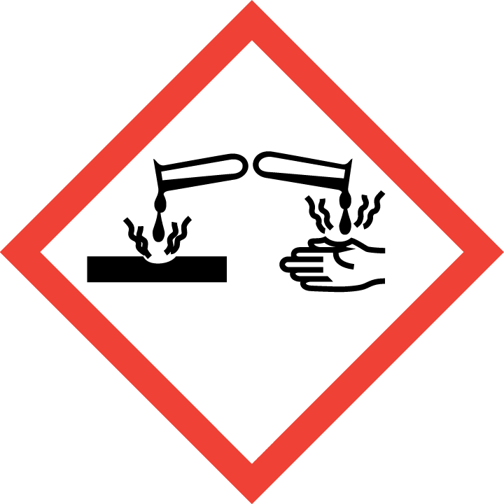

Signal word : DANGER

Hazard statement :

H315- Causes skin irritation.

H318- Causes serious eye damage.

H412- Harmful to aquatic life with long-lasting effects

Precautionary statement:

Prevention:

P264- Wash hands thoroughly after handling.

P280- Wear protective gloves/eye protection/face protection

P273- Avoid release to the environment

Response:

P302 + P352- IF ON SKIN: Wash with plenty of soap and water

P332 + P317- If skin irritation occurs: Get medical help.

P362 + P364 - Take off contaminated clothing and wash it before reuse

P305 + P354 + P338- IF IN EYES: Immediately rinse with water for several minutes. Remove contact lenses, if present and easy to do. Continue rinsing.

P317- Get medical help

Storage:

No special measures required.

Disposal:

P501- Disposal of contents / container in accordance with national regulations

**2.3. Other hazards**

None known

**3. Composition/information on ingredients**

**3.1. Substance**

**-**

**3.2. Mixture**

Information on ingredients / Hazardous components

|  |  |  |  |
| --- | --- | --- | --- |
| Chemical Name | CAS-No | Concentration (%) | Classification GHS |
| JL-120-2  (H-15: Lấy H300 làm cơ sở phân loại) |  | 10.2 | Skin Irrit.2, H315.  Eye Dam.1 H318.  Echa.com |
| Polyoxyethylene Tridecanyl Ether  H-298 | 9043-30-5 | 3.3 | Acute Tox- Oral.4, H302  Skin Irrit.2, H315.  Eye Dam.1 H318.  Aquatic chronic 2, H411  <https://echa.europa.eu/substance-information/-/substanceinfo/100.105.536> |
| Sodiumdodecyl benzenesulfonate  (DBN 90%),H-249 | 25155-30-0 | 1.1 | Acute Tox- Oral.4, H302  Skin Irrit.2, H315.  Eye Dam.1 H318.  https://echa.europa.eu/brief-profile/-/briefprofile/100.042.422 |
| Alcohols, C12-14, ethoxylated  (Alkyl alcohol ethoxylate,H-39, EO=9) | 68439-50-9 | 2.2 | Acute Tox- Oral.4, H302  Eye Dam.1, H318.  ECHA |
| Amides, C12-18, N,N-bis(hydroxyethyl) | 68155-06-6 | 0.83 | Skin Irrit.2, H315.  Eye Dam.1 H318.  https://echa.europa.eu/substance-information/-/substanceinfo/100.062.649 |
| Isopropyl alcohol | 67-63-0 | 2.5 | Flam.Liq. 2, H225  Eye Irrit. 2, H319  STOT-SE 3, H336  (Refer to https://echa.europa.eu/brief-profile/-/briefprofile/100.000.601) |
| urea |  | 3 | Not classified |

**4. First aid measures**

**4.1. Description of first aid measures**

General advice : If medical advice is needed, provide SDS document to physician.

Inhalation : Remove the victim from exposure or move to well- ventilated area.

If there is difficulty in breathing, medical advice is required.

Skin contact : After contact with skin, wash with plenty of soap and water.

Remove contaminated clothing, shoes and leather accessories.

Eye contact : Rinse cautiously with water for several minutes. Remove contact lenses, if present and easy to do. Continue rinsing. If eye irritation persist –Get medical advice/ attention .

Ingestion : In case of swallowing, rinse mouth, drink plenty of water. If feel unwell, seek medical advice.

**4.2. Most important symptoms and effects, both acute and delayed**

Symptoms : no special hints

**4.3. Indication of any immediate medical attention and special treatment needed**

Treat symptomatically.

**5. Fire-fighting measures**

**5.1. Extinguishing media**

Suitable extinguishing media : fine water spray, foam, dry powder, CO 2

Unsuitable extinguishing media : no data available.

**5.2. Special hazards arising from the substance or mixture**

In the event of fire the following can be released: carbon monoxide, carbon dioxide.

**5.3. Advice for firefighters**

On burning, fire fighter should wear self-contained breathing apparatus if risk of exposure to product of combustion.

**6. Accidental release measures**

**6.1. Personal precautions, protective equipment and emergency procedures**

Use personal protective equipment. Do not touch or walk through spilled material.

**6.2. Environmental precautions**

Take up and fill into a closable container. Prevent run off into drains and waterways.

**6.3. Methods and material for containment and cleaning up**

Take up liquid spill into absorbent material, eg: soil, sand and other non-flammable absorbent material.

**7. Handling and storage**

**7.1. Precautions for safe handling**

Advice on safe : wear protective equipment when working.

handling

Hygiene measures : Do not eat, drink or smoke when working. Wash hands before

breaks and after work.

General protective : Do not inhale gases/ vapors/ aerosols. Avoid contact with eyes and

measures skin.

**7.2. Condition for safe storage, including any incompatibilities**

**Prevention of fire and explosion**

Information : no special measures required.

**Storage**

Information : none

Further Information on storage conditions:

Keep container tightly closed and store in a cool, dry well- ventilated location.Store away from heat, flames, ignition sources and incompatibles. Check regularly for leaks.

**8. Exposure controls / Personal protection**

**8.1. Control parameters**

Exposure limit(s)

|  |  |  |  |  |
| --- | --- | --- | --- | --- |
| Ingredient | CAS-No | Statutory basis | Value type (From of exposure; Expressed as) | Occupational exposure limit |
| 2-Propanol (Isopropanol) | 67-63-0 | (Decision.No.3733/2002/QD-BYT) | TWA | 350 mg/m3 |
|  | (Decision.No.3733/2002/QD-BYT) | STEL | 600 mg/m3 |

**8.2. Exposure controls**

Appropriate : operate in well- ventilated area.

engineering controls

Personal protective equipment

Eye protection : wear safety goggles.

Hand protection : protective gloves.

Body protection : protective working clothes and safety shoes.

Respiratory : wear respirator

protection

**9. Physical and chemical properties**

**9.1. Information on basic physical and chemical properties**

Physical state or appearance: liquid

Color : colorless.

Odor : odorless.

Odor Threshold : no data available.

pH of 1% liquid (25°c) : 6.0-8.0

Melting point : no data available.

Boiling point : no data available.

Flash point : > 95°c

Evaporation rate : no data available.

Flammability : no data available.

Upper Explosion/Ignition limit: no data available.

Lower explosion limit : no data available.

Vapor pressure : no data available.

Relative vapor : no data available.

Relative density : no data available.

Solubility : soluble in water.

Partition coefficient : no data available.

(n-octanol/water)

Autoignition : no data available.

temperature

Thermal : no data available.

decomposition

Viscosity, kinematic : no data available.

Viscosity, Dynamic : no data available.

Oxidizing properties : no data available

**9.2. Other Information**

Density : $≈$ 1.0 g/cm3 (25°c)

Metal corrosion : no data available.

**10. Stability and reactivity**

**10.1. Reactivity**

Stable in normal room temperature

**10.2. Chemical stability**

The product is stable under normal conditions.

**10.3. Possibility of hazardous reactions**

No dangerous reactions known

**10.4 Conditions to avoid**

Heat, flames, ignition sources and incompatibles.

**10.5. Incompatible materials**

Avoid contact with strong acids and oxidizing agents.

**10.6 Hazardous decomposition products**

Carbon dioxide and carbon monoxide may form when heated to decomposition.

**11. Toxicological information**

**11.1. Information on toxicological effects**

Acute toxicity (oral) : not classified.

Acute toxicity : not classified.

(inhalation)

Acute toxicity (dermal) : not classified.

Irritation/corrosion : Causes skin irritation.

of the skin

Serious eye damage/ : Causes serious eye damage.

eye irritation

Skin sensitization : not classified.

Repeated dose toxicity : not classified.

**CMR assessment**

Carcinogenicity : not classified.

Mutagenicity : not classified.

Teratogenicity : not classified.

Toxicity to reproduction: not classified.

Specific Target Organ : not classified.

toxicity-single exposure

Specific Target Organ : not classified.

toxicity-Repeated exposure

Aspiration hazard : not classified.

**12. Ecological information**

**Ecotoxicology Assessment**

Acute aquatic toxicity: not classified.

Acute chronic toxicity: Harmful to aquatic life with long-lasting effects

**12.1. Toxicity**

No data available.

**12.2. Persistence and degradability**

Biodegradability (BOD5/ COD): No data available.

Biochemical oxygen demand (BOD5): No data available.

Chemical oxygen demand (COD): No data available.

**12.3. Bioaccumulative potential**

No data available.

**12.4. Mobility in soil**

No data available.

**12.5. Other adverse effects**

No data available.

**13. Disposal considerations**

**13.1 Waste treatment methods**

Waste from residue: Disposal should be in accordance with local regulations and legislation.

Contaminated packaging: Dispose of empty contaminated containers in accordance with regulations and legislation.

**14. Transport information**

**D.O.T Road/Rail**

UN number : not applicable.

UN proper shipping name: not applicable.

Hazard label: not applicable.

Transport hazard class (es): not applicable.

Packing group : not applicable.

Transport in bulk : not applicable.

Special precaution for user: not applicable.

**Air transport ICAO-TI/IATA-DGR**

UN number : not applicable.

UN proper shipping name: not applicable.

Hazard label: not applicable.

Transport hazard class (es): not applicable.

Packing group : not applicable.

Transport in bulk : not applicable.

Special precaution for user: not applicable.

**Sea transport IMDG**

UN number : not applicable.

UN proper shipping name: not applicable.

Hazard label: not applicable.

Transport hazard class (es): not applicable.

Packing group : not applicable.

Environmental hazards (Marine pollutant): yes.

Transport in bulk : not applicable.

Special precaution for user: not applicable.

**15. Regulatory information**

**15.1 Safety, health and environmental regulations/ legislation specific for the substance or mixture.**

* Regulation on classification and labeling of chemicals - Circular Number 32/2017/TT-BCT. Date issued : 28/12/2017.
* Regulations on the list of hazardous industrial goods to be packed in the process of transporting and transporting dangerous industrial goods by road, rail and inland waterway transport - number: 44/2012/TT-BCT - Date issued 28/12/2012
* National technical standard for ambient air quality - QCVN05:2013/BTNMT
* National technical regulation on some hazardous substances in the surrounding air - QCVN06:2009/BTNMT
* Regulations on the labeling of chemicals based on GHS according to Circular No. 32/2017 / BCT
* Decision, No.3733/2002/QD-BYT.

**16. Other information**

The information in the sheet was written based on the best knowledge and experience currently available but without liability.

SDS prepared on: March 25, 2021

Revision date :

Version 1.0

Legend

TWA: Time Weighted Average

IATA: International Air Transport Association

ICAO: International Civil Aviation Organization

IMDG: International Maritime Dangerous Goods

Flam. Liq. 2: flammable liquid, hazard category 2

Acute Tox- Oral.4: acute toxicity oral, hazard category 4.

Skin Irrt.2: Skin irritation, category 2

Eye Dam.1: eye damage, hazard category 1

Eye Irrit.2: eye irritation, hazard category 2

STOT SE 3: Specific target organ toxicity- single exposure, hazard category 3

Aquatic Acute.1: Aquatic acute, hazard category 1

Aquatic chronic 2: Aquatic chronic, hazard category 2.

Aquatic Chronic.3: Aquatic chronic, hazard category 3

H225- Highly flammable liquid and vapor

H302- Harmful if swallowed

H315- Causes skin irritation.

H318- Causes serious eye damage.

H319- Causes serious eye irritation.

H336- May cause drowsiness or dizziness

H411- Toxic to aquatic life with long-lasting effects

H412- Harmful to aquatic life with long-lasting effects